EHS Assessment Policy

Name of Policy / Procedure | Assessment Policy
Issue date | September 2026
Review date | September 2028
GB committee responsible for the policy / procedure | Curriculum
Staff member responsible for writing, reviewing and updating the policy / procedure | Assistant Headteacher
Person responsible for monitoring implementation of the policy / procedure | Headteacher
Workload impact assessment (see below) | High

Teacher Workload Impact Assessment
High impact: Policy implemented by teachers on a daily / weekly basis
Medium impact: Policy implemented by teachers on a monthly / termly basis
Low impact: Policy implemented by teachers on an annual basis
n/a Policy is not implemented by teachers.


Policy: Rationale

All assessment and feedback should help learners to improve their learning. The use of good quality, consistent assessment and feedback plays a significant role in promoting improvement from learner level through to system level. It needs to be valid, reliable, manageable and meaningful for teachers, learners and other stakeholders. The assessment within the school, and across primary/secondary clusters, is designed to provide coherent information that demonstrates a shared understanding so that it can be used consistently across subjects and year groups. There are two key forms of assessment:

- Assessment for Learning (Feedback)
- Assessment of Learning – which will also support Assessment for Learning

Policy Summary:

Every book should show:
✔ Clear learning intentions and success criteria
✔ Evidence of purposeful planning (tasks matched to the class)
✔ High quality work over time
✔ Regular assessment for learning
✔ At least one QMA with WWW/EBI - within data cycles
✔ Time given for DIRT and meaningful student responses (red pen)
✔ Literacy codes used in extended writing
✔ Feedback that improves learning (not just presentation)
✔ Evidence of improvement over time
✔ Opportunities for self and peer assessment

Books should clearly demonstrate:
Purposeful planning → Clear learning → Feedback → Response → Improvement
Quick Self-Check for Staff
Ask yourself:
- Can I see progress over time?
- Have students acted on my feedback?
- Does my work reflect my understanding of this class?
- Are misconceptions being addressed?
If yes → You are following the Elfed Way

Policy: Principles
- All lessons will be introduced with a clear explanation of the learning intention. This will then be followed up with clear success criteria. This can be teacher led or co-constructed.
- Before providing feedback, teachers should provide high quality instruction, including the use of formative assessment strategies (Teacher Feedback to Improve Pupil Learning, EEF, June 2021).

- Quality Marked Assessment, also known as a progress checkpoint, will contain clear success criteria, lead to feedback which will increase the dialogue between student and teacher, in order for students to make progress.
- Feedback has a clear focus; it is closely connected to the learning outcomes and success criteria.
- Assessment and feedback is diagnostic: it helps students to improve their work and provides them with the next steps in their learning so they make progress.
- Quality Marked Assessment and feedback promotes learner confidence by capturing where and how they are making progress in their learning. Feedback also helps students establish where they currently sit on the progression scale, how they got there and what they need to do to move forward.
- Where appropriate, feedback provides opportunities for peer and self-assessment.
- Comments are focused on improvements in learning and move away from surface features, such as presentation or perceived effort.
- Students are provided with the opportunity to enable them to improve and extend their learning by responding to feedback. This will happen in structured DIRT sessions following a quality marked assessment or series of assessments. This piece of work will be known as “My Progress Pathway Progress Page”.
- When reviewing and evaluating written feedback, the focus should be on the impact that feedback has on students’ learning and progress.
- Students should be taught and encouraged to check their own work by understanding the success criteria, presented in an age-appropriate way, so that they complete work to the highest standard.
- Marking of extended writing pieces will utilise our EHS literacy codes
- Fairness and accessibility (under The Equality Act 2010 and Public Sector Equality Duty: a fair assessment should not discriminate against sub-groups of candidates or give an advantage to other groups. Assessment should be free from bias, inclusive, non-discriminatory and accessible. It should also be fair to those who rely on the results (such as employers, further education colleges and universities) by accurately assessing what a learner knows, understands and can do.
- All departments will complete one summative assessment per term. Marks will be recorded in department marksheets
- Validity: a valid summative assessment task will measure the intended learning outcomes of a topic/unit of study.
- Reliability: A reliable assessment is one that will produce the same outcome each time it is used in a similar context.
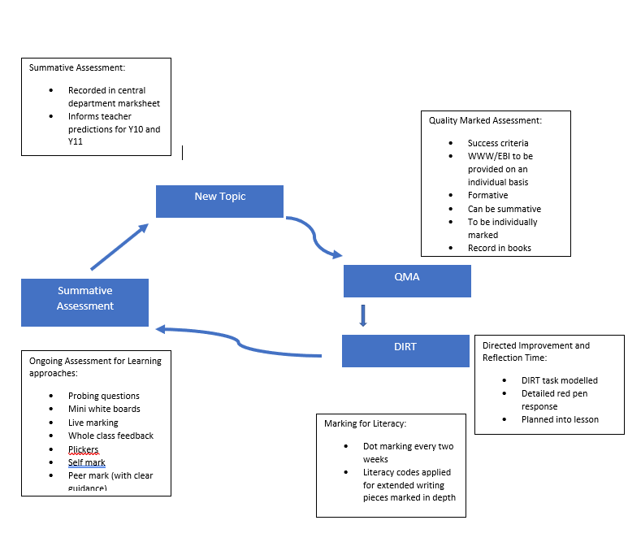

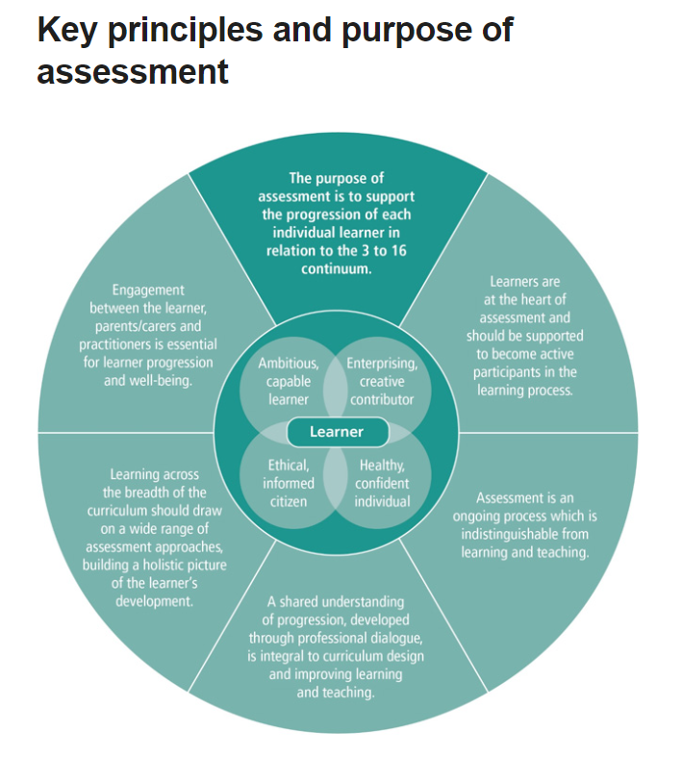

Procedure: Assessment for Learning (Feedback)

Assessment for Learning is used to move learning forward. It can include the following practices:

- Verbal Feedback
- Probing questions to develop deeper understanding
- Formative WWW/EBI Teacher Marking via Quality Marked Assessments (QMAs) which include clear success criteria
- Peer/Self-Assessment e.g. Think, pair, share
- Literacy Feedback, including Marking for Literacy with extended writing pieces
- Dot marking once every two weeks. (Optional)

Verbal Feedback
Verbal feedback is a highly valuable form of formative feedback that is part of high quality instruction; teachers should ensure that verbal feedback is in line with the principles outlined above.

Formative WWW/EBI Teacher Marking via Quality Marked Assessments (QMAs)

Quality Marked Assessments (QMAs) / Progress Checkpoints
All students complete Quality Marked Assessments (QMA) during units of work. The task and success criteria for QMAs are shared with students and parents/carers on unit overviews. QMAs are assessment tasks that are carefully marked by teachers, where students are given formative feedback that they must respond to. The focus is on moving learning forward.
.
- When undertaking Formative WWW/EBI Teacher Marking, students’ work is formatively marked in green pen for:
  - a ‘What Went Well’ (WWW) comment: a formative comment that focuses on the task, subject or self-regulation strategies

  - an ‘Even Better If’ (EBI) task: this is a subject specific task that is actionable and furthers learning and/or addresses misconceptions. It should support continuous improvement and encourage a growth mindset. The EBI task can ask students to revisit a task that has been previously completed, or be built into the next lesson’s task.

- Lesson time must be allocated for students to respond to the EBI task, as well as to respond to the literacy feedback given by the teacher: DIRT (Dedicated Improvement and Reflection Time). ‘Only then will the feedback loop be closed so that student learning can progress.’ (EEF, June 2021). DIRT is to be modelled by the class teacher to ensure students fully understand how to successfully respond to their feedback.

- Teachers will decide when feedback is given, informed by purposeful planning – a clear understanding of the class, the individual learner and the intended learning. This will take into account the nature of the task, the needs of individual students and the collective understanding of the class

- Student responses should be in red pen.

- Middle leaders/teachers may wish to make use of student friendly success criteria, assessment ladders, codes, stamps/stickers and other resources to reduce workload and scaffold students’ understanding of requirements.

Peer and Self-Assessment
In addition to formative teacher marking, teachers will provide opportunities for peer and self- assessment. Peer and self-assessment tasks are undertaken most effectively when they involve careful training and scaffolding for students, and support teacher feedback practices such as WWW and EBI feedback. All written peer and self- assessment should be verified by teachers.

Literacy Feedback

- All teachers/subjects have a responsibility for the development of students’ literacy skills so that students are confident and competent in speaking, listening, reading and writing using Standard English. The Curriculum for Wales 2022 outlines that literacy skills “are essential for learners to be able to participate successfully and confidently in the modern world.” (p.11)

- When marking for literacy, ‘teachers should distinguish between a ‘mistake’ – something a student can do and normally does do correctly, but has not on this occasion – and an ‘error’ which occurs when answering a question about something that a student has not mastered or has misunderstood. (‘A Marked Improvement’ EEF, April 2016).

- Mistakes should be identified using ‘Marking for Literacy’ codes when marking extended writing tasks.

- Where mistakes and errors are numerous, teachers should use their professional judgement to identify which mistakes and errors are most appropriate to identify and provide feedback to the student.

- The teacher will determine an appropriate time for students to respond to the literacy feedback given by the teacher, in order to close the ‘feedback loop’ (EFF, June 2021).

Marking for Literacy codes

C | Incorrect use of capital letters
NP / / | Paragraph needed (indicate where paragraph needs to be)
Sp | Spelling error
P | Punctuation missing or incorrect punctuation
WW | Wrong word
WT | Wrong tense

- As part of their subject specific guidance, middle leaders should have a clear strategy for how they support the development of students’ literacy skills. This will outline:

  - how students are supported in developing their advanced reading skills in
line with our whole school priority from September 2026. Elfed High School's "READ IT" approach has been launched in September 2026 providing a step by step guide on how to teach advanced reading skills across all subjects.

.
Assessment of Learning

Assessment of Learning provides information that is used to inform strategic planning, leadership and accountability as well as being used by individual learners and parents/carers. It provides evidence of individual, whole class, cohort and school levels.

There is a planned programme of Assessment of Learning for all students. Assessments are summatively marked and inputted into subject based tracking systems e.g. SIMS (Years 7-11). Assessments are designed in line with the principles of progression and description of learning. Assessments should be designed to showcase appropriately challenging skill development and help students understand how to move their learning forward.

Standardisation is an ongoing process used by all departments to ensure consistency in the assessment of specific tasks between teaching groups. There are calendared sessions to moderate assessments, as outlined in the MER Programme.

External moderation reports are used to confirm areas of good practice and identify areas for development. In Year 7 - 9, learner profiles of exemplar samples of work are retained and shared within subject areas. Furthermore, these materials are also used to support the training of NQTs and ITTs. All cross curricular leads regularly attend cluster meetings with the Buckley Mynydd Isa Consortium to monitor and develop effective approaches to cross curricular skills across all AOLE’s.

Standardised testing includes CATS for Year 7, Personalised Assessments in English and Maths during years 7, 8 & 9. Target setting takes place at the end of Year 9 to help to form their target grades.

Assessment Procedures

Collection of Assessment Data

There are 3 whole school data drops – weeks 10, 20 and 30. Using statements of what matters, principles of progression and descriptions of learning across all AOLE’s, we have identified the following key skills as a focus for development through our teaching and learning journey from Year 7 – 11:
- Growing my Knowledge
- Understanding big ideas
- Building skills
- Making connections
- Being an effective learner
For Maths only, the following proficiencies:
- Conceptual understanding
- Communication using symbols
- Fluency
- Logical Reasoning
- Strategic competence

For each unit of work, subject teams are required to do the following:
- Identify three key skills that will be developed through the unit of work being delivered
- Collect progress data on the development of these chosen skills through a chosen activity/series of activities. The data collection activities must be agreed in department teams
- Data is entered on to our progress tracker as a RAG.
- Success criteria for the RAG’s is to be decided as a subject team and saved in subject areas as a reference point
- Each RAG is entered as a score. R = 5, A = 10 and G = 15. At week 10, 20 and 30, a mean calculation is taken to establish where on the progression scale each student sits for each subject. The progression scale is as follows:



Years 7 -11 -Progress Indicators
In years 7 -11 standardised data (CATs, Personalised Assessments, Progress Tests, Reading Test scores) are used to generate a stanine. This acts as the starting point for the student’s progress journey. Student’s stanines will be compared to their progress data at each data point for 7, 8 and 9, and compared to GCSE targets for 10 and 11, to ensure that each student is making suitable progress from their starting point. Student’s stanine scores will appear on the progress tracker.

Years 10 & 11 Grades
End of course Predicted Grades are to be entered for each course followed. These predictions are to be based upon the assessed work of exam style questions. Teachers enter a relevant assessment grade for that subject, i.e. L1P into the progress tracker.

Forming the assessment judgments/predictions

Years 10 and 11 will have frequent in class opportunities to complete assessments of past paper style questions and tasks, which will inform the predicted grades. They will also have formal Trial Exams during the school year, as per the calendar. These are tracked at a subject level in SMID.

Reporting Progress.

Elfed High School provides both qualitative and quantitative information in annual Progress Reports to parents/carers, informing them of progress in all subjects. These reports provide learner specific information.

The school calendar identifies key dates for assessment, and Twilight sessions are used to support accurate assessment of learner outcomes.

Termly Progress Reports
Termly progress updates will be sent out three times a year and contains the following information:
- Progression code information for each subject studied i.e. is your child emerging, widening, developing, securing or embedding in each subject
- A learning characteristic:
1 | Outstanding Learner
2 | Engaged Learner
3 | Passive Learner
4 | Disengaged Learner
5 | Significant Cause for Concern

- A wellbeing lesson comment. This is based on progress through the current wellbeing unit for that term
- A form tutor comment based on uniform, attendance and punctuality as well as a general student welfare comment
- Attendance percentage at time of reporting
- A website link to our unit overviews, GCSE specifications and parent, carer advice and guidance which helps students, parents and carers understand how to move their learning forward in each subject.

Analysis of Data

- Assessment information is collected in line with the MER system and is used to inform us about the level of progress being made by the students.
- After every collection of assessment information, the data is analysed thoroughly and discussed with key stakeholders. Heads of Subjects identify strengths and priority areas requiring action areas for each year group. These findings are reported to SLT through data meetings.
- SMID information is shared with Learning Directors, the School Leadership Team, Heads of Subject, Form Tutors and School Governors.
- The main aim from this assessment period is to ensure students are making progress in the development of their knowledge and skills. In years 10-11 it is to ensure they are making expected progress towards their target grades.
- Student groups are also analysed to judge progress.
- Students at an individual level also form the focus of data analysis and progress meetings.

Assessment Terms

Target Grade: a realistic target grade based on standarised scores, past
Test results and QMA data

Predicted Grade/Level: a realistic prediction, grounded in evidence, of the likely grade/level at the end of the academic year/GCSE course based on current performance

Grades A* – G (U): indicate GCSE grades for Year 10 and 11

L1/L2 P/M/D: indicate Level 1 or Level 2 vocational courses at Pass,
Merit or Distinction

Grades 3, 2 and 1: indicate Entry Level assessments (3 is high)

Learning Characteristics: Replacing Attitude to Learning and Integral Skills for students in years 7-11.
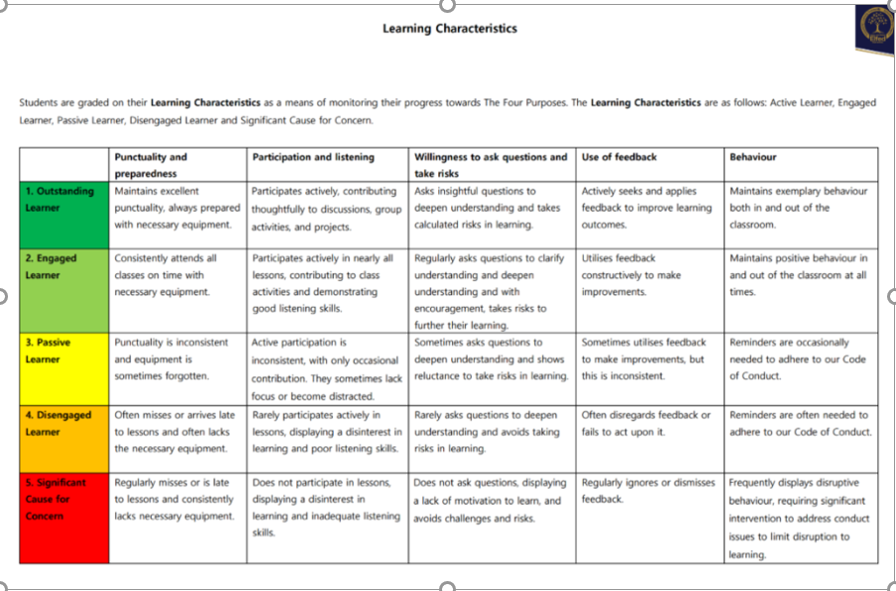

Teaching and Learning at Elfed High School

“The Elfed Way”

When you walk into any lesson, you would expect to see the following:

- Clear learning intentions shared with the students. Students will know the learning aim for that lesson
- Success criteria established and shared so that students know what success looks like for that lesson
- Extensive assessment for learning to establish understanding
- Effective teacher modelling
- Students working independently, producing quality work as per the success criteria shared earlier in the lesson

Progress Checkpoint (Quality Marked Assessment) feedback sheet will be as follows:

At the mid point of a unit, teachers are required to carry out a quality marked assessment. This is designed by each individual teacher and should be designed to assess progress through the current unit and crucially, should provide the teaching member of staff with information that will help inform the most appropriate route through the rest of the journey. Every QMA is to be deep marked and feedback provided that links directly to the principles of progression and the unit overview.

Responsibilities of Head of Department:

- To ensure there is clear guidance around assessment design for QMA’s. QMA’s are an opportunity to showcase progression through your unit and should provide the appropriate scaffolds, stretch and challenge. Consistency across departments shold be evident.
- Regular moderation of QMA’s to take place during department time.
- Clear guidance as to when QMA’s should be taking place.
- Clear guidance, support and monitoring of delivery of the new feedback process.

Responsibilities of teaching staff:

- To ensurer your QMA’s follow the criteria and expectations set by your HOD.
- To ensure the appropriate scaffolds, stretch and challenge is present in your QMA
- To take part in regular departmental moderation
- Ensure you follow your department’s schedule of QMA delivery
- Ensure you engage fully with the Elfed feedback process

Elfed Feedback Process

- Assessment is completed. Departments are free to design assessments that best suit the unit of work being completed. Assessments must be robust, challenging and fully considerate of the principles of progression you are focusing on.
- Assessmenst will be deep marked and fed back on using the following:

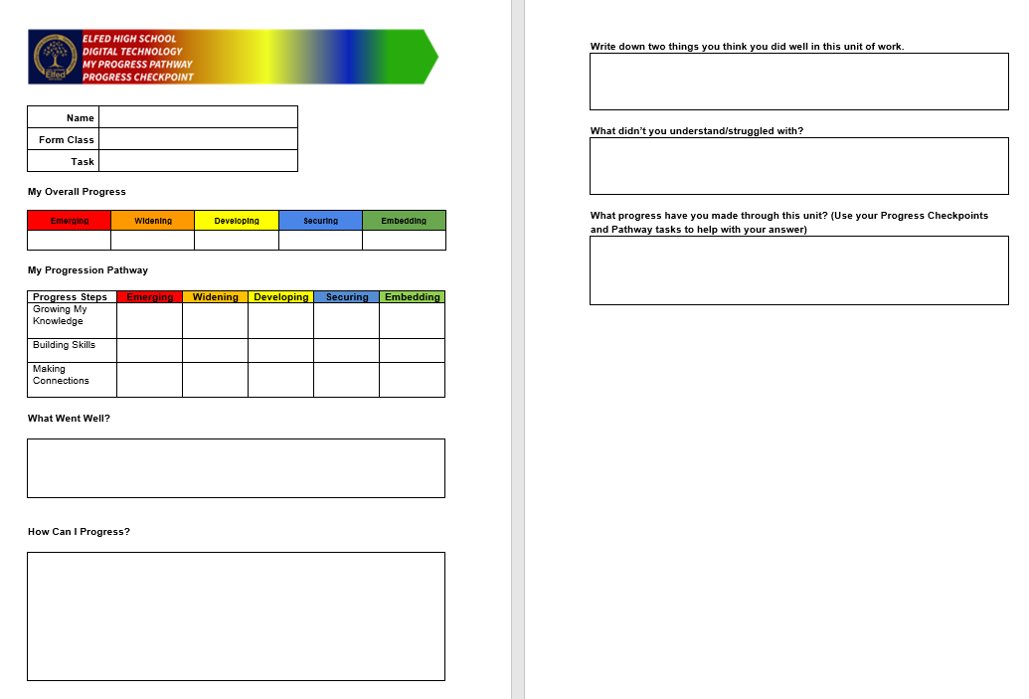

- All departments must complete the top part of the feedback sheet. Departments then have the autonomy to present the DIRT task in the way that best suits the subject and task in hand.
- Thorough DIRT is then to be completed. It should last at least 45 minutes. DIRT will be known as “My Progress Pathway Progress Page” and the following sticker will act as the header for that piece of work:

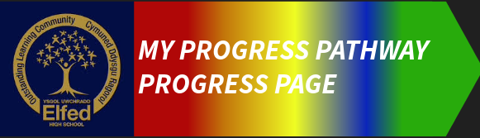

- Departments are free to assess progress towards identified principles of progression on an individual basis, through three bespoke tasks, or through a single, well designed QMA. The above sheet and follow up work is not to be completed until all three principles have been focussed on.

