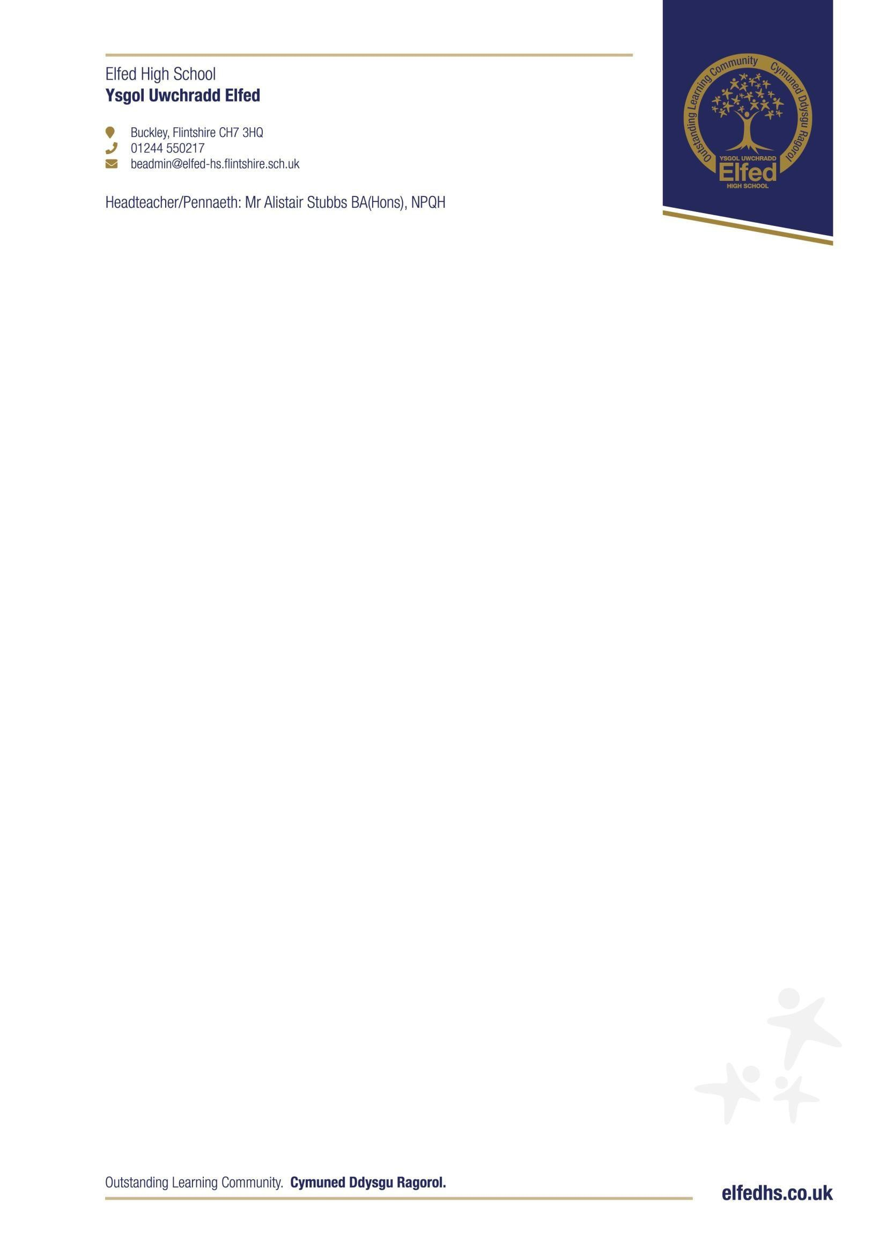

2026 – 2027
Holiday dates for students
TERM | TERM BEGINS FOR  STUDENTS | HALF TERM HOLIDAY |  | TERM ENDS
TERM | TERM BEGINS FOR  STUDENTS | Begins | Ends | TERM ENDS
Autumn | Wednesday | Monday | Friday | Friday
2026 | 2nd September 2026 | 26th October 2026 | 30th October 2026 | 18th December 2026
Spring | Tuesday | Monday | Friday | Friday
2027 | 5th January 2027 | 15th February 2027 | 19tth February 2027 | 19th March 2027
Summer | Monday | Monday | Friday | Friday
2027 | 5th April 2027 | 31st May 2027 | 4th June 2027 | 16th July 2027
School is closed on:
May Day – Monday 3rd May 2027 Buckley Jubilee – Tuesday 13th July 2027
School is closed for Staff Training on:
Tuesday 1st September 2026
Friday 23rd October 2026
Monday 4th January 2027
Tuesday 13th July 2027
Monday 19th July 2027
Tuesday 20th July 2027

